**Cholpon Kudaibergenova**

**Cornwall report**

**Genesis**

The peninsula is dominated by sedimentary rocks of the Devonian and Carboniferous Periods and includes cotemporaneous minor basaltic volcanic rocks. Into these have been intruded Late Carboniferous to Permian age granites and associated subvolcanic rocks. The geology of the region has led to a variety of scenery ranging from dramatic cliffscapes of sedimentary rocks, castellated granite, pillow lavas, granitic tors and drowned valleys. Tectonic plate movement over the past 400 million years has shifted the position of Cornwall and Devon from well south of the equator to its present geographical position located at 50 degrees N.

The Devonian and Carboniferous sedimentary rocks comprise mudstones,siltstones, sandstones, minor conglomerates and rare limestones as well as basic intrusive (gabbro) and extrusive (spillites and tuffs) volcanic rocks known locally as greenstones.

The Devonian rocks of the region are separated by a broad zone of Carboniferous rocks (the Culm) in central Devon. Offshore lie Permian and Cretaceous sedimentary rocks. At the extreme southeast of the region lies the Lizard peninsula, a fragment of Devonian oceanic floor of mainly ultrabasic rocks, most of which have been altered to serpentinite. Little of the Pre-Devonian basement is observable apart from the Man O’ War Gneiss at the Lizard Point which is dated at 500 million years (Ma), Ordovician quartzites in the Roseland Breccia formation and rare xenoliths in the basaltic rocks.

The sediments have been deformed (folded) both prior and during the period of granite intrusion with later minor deformation. Most of the Devonian sediments have undergone low-grade regional metamorphism to sub-greenschists (development of chlorite) facies. Slates formed during this period are now exploited at Delabole. Occasionally fossil remains of the Cyrtospirifer verneulli (‘Delabole butterfly’) are found in the quarry. The major period of deformation took place during the Variscan orogeny (mountain building). It was in the latter part of this orogeny that the granites were intruded with associated tin and copper mineralization, forming the Cornubian Orefield.

During the Permian to Cretaceous deposition again took place in basins developed on Devonian and Carboniferous deformed rocks, forming sandstones and conglomerates with minor volcanic rocks and later chalk. The only exposures near the Cornubian Orefield are the New Red Sandstones to the northeast in Devon, the rest lie offshore. During the Tertiary, fault activation resulted in basins now evident as isolated Oligocene, Miocene and Pliocence sands and clays and deep weathering of the granite to form kaolin deposits. During the Quaternary the Ice sheet probably touched the north coast of the peninsula and Isles of Scilly and the area was subjected to periglacial acivity.It was during this period that sea-level changes lead to raised beaches and solifluction formed head deposits. Postglacial sea level rise produced drowned valleys or rias forming deep estuarine inlets.

**Zoning**

Early workers in the field of geology and mining had recognised that both copper and tin mineralization was closely associated with the granite, and lead, zinc and antimony were further away due to a temperature gradient. It was therefore concluded that hydrothermal activity graded the metallic and gangue minerals into a series of concentric zones around the granite intrusions. This would not only apply to the distance from the granite but also in depth – hence the expression ‘tin under copper'.

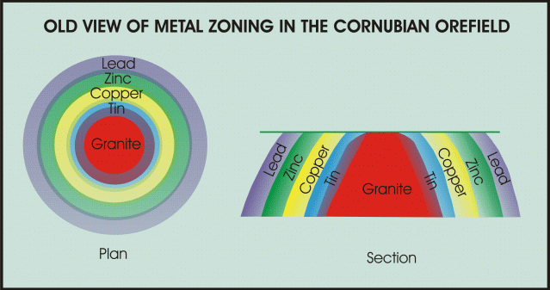

Some form of zoning would appear to have existed in the St Just- Pendeen district at the Geevor and [Levant Mines](http://freespace.virgin.net/levant.mine/). However, it is an oversimplification. A model of emanative centres where maximum hydrothermal activity took place was proposed later. The model illustrates metal production distribution within the orefield.

The current theory is one of convective cells, which progressively collapse due to the loss of thermal insulation due to erosion and a reduction in heat generated in the granite and by radiogenic decay. The collapsing cells lead to the overprinting of earlier high temperature mineralization by later low temperature mineralization.

**Tectonic setting**

The geology of the region shows evidence for the formation of a series of rift basins and local ocean lithosphere that was subsequently incorporated in the Variscan orogen (mountain-chain). The orogen was generated by the convergence of Africa and Europe.

Following collision and continental shortening and thickening, the continental lithosphere was extended once again immediately prior to granite emplacement.

During the Lower to Mid Devonian, the region was affected by a period of rifting with the formation of sedimentary basins and deposition of deep marine mudstones and sandstones (turbidites). Significant basaltic magmatism (the generation and emplacement of magma and its solidification to igneous rock known locally as greenstones) also occurred. It was during this period that the oceanic floor, now preserved on the Lizard, was created. Changes in plate motion during the Mid- to Late Devonian brought about convergence between mainland Europe and Southern Britain. By the Late Carboniferous the Culm Basin in the north of the region was closed. The Carboniferous Period was marked by the development of major thrust faults and low-grade regional metamorphism of the Devonian rocks as they were incorporated into the Variscan mountain chain. Mudstones (pelites) were converted to schists and phyllites (slates). This produced at least one generation of folding and slately cleavage with quartz veins. The basaltic lavas were also metamorphosed into metabasites.

Towards the end of the Variscan orogenic episode, the previously thickened continental lithosphere underwent a period of NNW-SSE extension due to the reactivation of thrust faults, and the formation of ENE-WSW trending faults and fractures. As the crust thinned this resulted in the partial melting of the mantle generating lamprophyres, and the lithosphere generating granite.

During the Lower Permian ENE-WSW faults and joints were generated in both the granites and metasediments by extension. These fractures acted as a plumbing system for mineralizing fluids to exploit to form mineral bearing lodes. The mineralizing fluids had been generated by variable mixing between hydrothermal fluids exsolved from the granite melts and those in the contemporary groundwater system in country rocks, and to a lesser extent later radiogenic heat from radioactive elements in the granite, producing hydrothermal convection systems.

From the Permian, alluvial sedimentation took place in basins as the subsidence was controlled by the same extensional regime that controlled the granite generation and mineralization. During the Triassic to Cretaceous, episodes of E-W and N-S extension took place with rifting. As a consequence of this fluids from the basins (basinal brine fluids) were expelled and the mineral bearing waters formed crosscourse mineralization of mainly quartz, but also lead, zinc, barium, uranium, nickel, cobalt, silver, minor gold and rare palladium mineralization which cross-cut the tin-copper-tungsten veins.

Just prior to and during the Tertiary, the area was subjected to uplift of up to 1-1.5 km due to the thermal effects associated with the North Atlantic opening and possibly Alpine convergence. Any Mesozoic cover would have been lost during this event. During the Tertiary there was reactivation of the major NNW-SSE high angle faults and the development of Eocene and Oligocene pull-apart basins such as those at Bovey Tracey.

**Mineralization.**

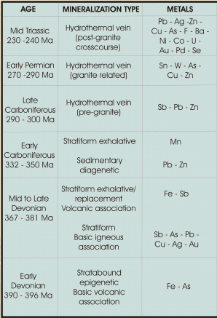The mineral deposits of the Cornubian Orefield have a variety of forms and characteristics. Most of the mineralization can be linked to the granites, although some deposits of East Cornwall and West Devon are pre-granite in age. These include the manganese deposits, stratiform lead-zinc ores, some lead-antimony and iron ores, and are either volcanogenic or metamorphic in origin.

Mineralization has been introduced into the rocks of Cornubia by the movement of hot to warm waters, known as hydrothermal activity, carrying elements in solution. These are known according to temperature and are:

* Hypothermal 300 – 500 degrees C,
* Mesothermal 200 – 300 degrees C,
* Epithermal 50 – 200 degrees C and found within 1 km of the surface.

**In the Cornubian Orefield the fluids range in temperature from:**

* Pegmatite and aplitic mineral deposits 300 – 400 degrees C (Sn/W)
* Greisen-bordered sheeted-vein systems 400 – 450 degrees C (Sn/W)
* Main-stage fissure vein mineralization (350 – 450 degrees C (Sn/Cu)
* Cross-course mineralization 200 – 350 degrees C (Fe/Pb/Ag/Zn).

**These fluids had been derived from:**

* Metamorphism (changes in the rock due to temperature and pressure)
* Magmatism (from magmas)
* Basinal expulsion (from the compression and burial of sediments in basins)
* Meteoric (surface) waters moving downwards from the surface.

All rocks contain water. The magma derived from the melting of sedimentary rocks of the Cornubian batholith was ‘wet' containing up to 8% water content.

Metal bearing elements were derived from:

* Melting of sedimentary rocks and the accumulation of fluid in the granite
* Circulation of waters through the country rocks and granite
* Expulsion of fluids containing metalliferous elements from sedimentary basins

When analysed all rocks contain traces of metals, for example recent investigation indicates that sedimentary rocks in Cornwall contain up to 15-25 ppm Cu, 10-20 ppm Pb, 110-130 ppm Zn, 15-30 ppm As, 3-4 ppm Sn and greenstones 45-65 ppm Cu, 30-35 ppm Pb, 170-270 ppm Zn, 16-35 ppm As, <10 ppm Sn (Dr N.LeBoutillier pers.comm.).

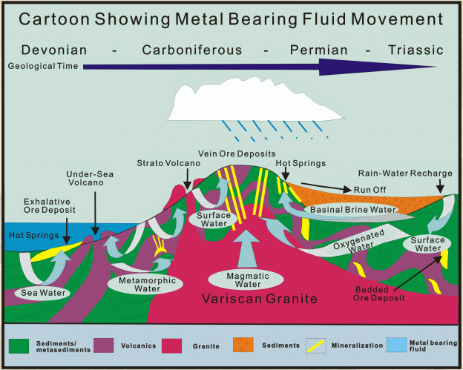

Initially, after intrusion of the granite the fluids were derived from an accumulation in the upper part of the granite and are known as magmatic volatiles containing boron and fluorine as well as metals. These volatiles concentrated on the margins of intrusion, particularly below small topographic highs known as cusps on the batholith. The build up of fluids pressure would later fracture the granite roof and surrounding rocks to form pathways for metal bearing waters. These would form loci known as emanative centres for mineralization. Hydrothermal convective systems, driven from heat from the granite and radiogenic activity (the decay of radioactive elements) developed in the country rocks. These circulating waters would scavenge metals from the country rocks as well as the granite and deposit them in fractures due to cooling, changes in pressure, and an interaction with the chemistry of the wall rocks. Hydrothermal activity leads to a concentration of the metal elements in narrow fractures. The convective cells last to this day as ‘hot' mineral bearing waters and were encountered in the last working tin mines of South Crofty and Wheal Jane. Other metal bearing fluids were derived from deepening sedimentary basins, which due to increasing pressure from the load of sediments above both heated and expelled them. Oxygenated water would also be provided from the surface from rainfall or seawater to recharge this fluid flow and interact with it.

The ground had to be prepared before the fluids could be transported and it was the process of fracturing and faulting due to changes in stress on the rock that provided the conduit or ‘plumbing' system. The stress was introduced during folding, granitic intrusion/cooling and displacement by faulting. Faulting, both normal and reverse would provide the greater space for mineral deposition to form lodes. The textures within the lodes are the result of open space filling followed by brecciation and recementation. Often within a vein there is evidence of many phases of mineralization, which occurred over a protracted period of time. The fluids, if under high pressure, could also fracture the rock by a process known as hydrofracturing providing further pathways. Mineralization from hydrothermal activity in the orefield lasted over a period of some 250 million years.

During the Mesozoic and Cenozoic deep tropical weathering of the mineralized lode systems lead to supergene enrichment with gossans. In the Quaternary, erosion took place of the deeply weathered tin-bearing veins and ore bodies. Subsequent transportation, concentration and deposition of heavy minerals lead to the formation of placer deposits of tin and minor wolframite containing trace amounts of gold.

The movement and concentration of ore bearing fluids produced an orefield that has produced a variety of metals, which include, tin (Sn), copper (Cu ), tungsten (W), lead (Pb), zinc (Zn), silver (Ag), antimony (Sb), nickel (Ni), cobalt (Co), bismuth (Bi), uranium (U) and iron (Fe), as well as the metalloid arsenic (As), and minor gold (Au) and palladium (Pd). The distribution within the orefield is shown below.

Mineralization associated with crosscourses has trends of both N-S and NNW-SSE in reactivated extensional fault systems. These can carry major lead-silver-zinc-fluorite-barite (as well as copper-antimony minerals) or rarely cobalt, uranium and nickel, plus or minus gold. However some low temperature mineralization (both mesothermal and epithermal) of this type is devoid of fluorite, as in the St Agnes-Perranporth area. The fluid depositing the mineralization has probably been derived from basinal brines from sedimentary basins. These fluids may have been partially transported by seismic pumping. Seismic activity or earthquakes would produce fluid expulsion along faults. Often crosscourses displace earlier lode systems and some are filled with clay or chalcedony, occasionally they can displace a lode up to 100 m.

Those low temperature deposits of lead-zinc-antimony-copper and traces of gold in northwest Cornwall are associated with volcanic rocks and are probably pre-granite in age. The metals they contain have been derived from the same rocks by the movement of pre-granite metamorphic fluids. Antimony minerals mined included jamesonite, bournonite and stibnite.

The iron mineralization in the Great Perran Iron Lode, in the St Agnes mining district, is in brecciated slates cemented by siderite, minor quartz and sphalerite. This style of mineralization may also predate granite mineralization and may have also formed from metamorphic fluids. The deposit has been oxidised to depths of 60 m to hematite and limonite.

Near Tourquay on the east coast of Devon is a rare outcrop of gold mineralization hosted in Devonian limestone. Carbonate veins, striking north west - south east, carry gold-palladium mineralization. The site is now a Site of Special Scientific Interest. The Au-Pd mineralization is associated with selenium and mercury minerals, some of which are extremely rare. The source of the mineralization has probably been derived from low temperature metal-bearing basinal brines. The mineralization is in fractures in close proximity to an unconformity with overlying Permian-Triassic Age sediments.

Other N-S trending iron oxide-carbonate quartz lodes and others of iron and uranium are considered to be associated with the process of kaolinization of the granite. In this case meteoric waters passing through the granite would have leached out the iron (from the mica), uranium and silica from the granite.

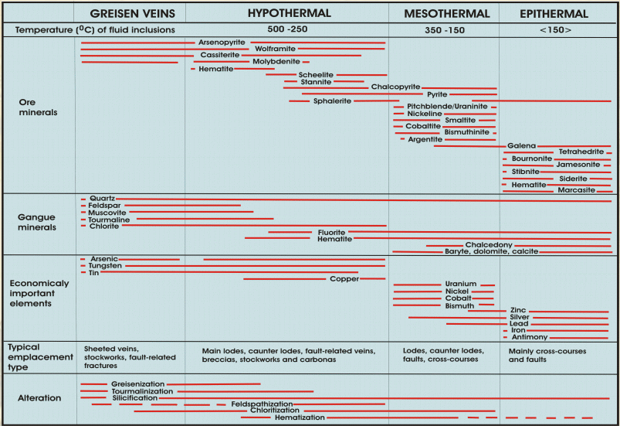

**Throughout the orefield five varieties of hydrothermal alteration can be recognised and these are:**

* Tourmalinization – where biotite micas and chlorite are replaced first followed by feldspar and muscovite mica.
* Sericitization – feldspars are altered to a potassium (K) mica and where the alteration continues to a quartz mica assemblage it is known as greisen.
* Chloritization – biotite mica is converted to chlorite.
* Alkali metasomatism – plagioclase feldspars are converted to K feldspars and muscovite mica.
* Argillization– feldpars are converted to clay minerals such as kaolin.

**Pegmatite-aplite and skarn mineralization**

Mineralization in pegmatites and aplites is the earliest form of mineralization. It is intimately related to the granite intrusion and are often found in the roof of the granite or as sills (sub-horizontal intrusions) in the country rock. Trace amounts of ore minerals occur in such bodies and these are loellingite, molybdendite, native bismuth, cassiterite, wolfamite, columbite and uraninite. This type of mineralization indicates a mixture of magmatic and hydrothermal activity.

Other fluids of magmatic origin have been responsible for skarn development. These have developed in calcareous sediments which are predominantly volcanic in origin. It has produced rocks containing epidote, garnet and axinite, plus or minus magnetite. Some contain cassiterite with tourmaline in economic concentrations and have been exploited as at the Grylls Bunny in the St Just-Pendeen district in west Cornwall.

**Greisen mineralization**.

This is the first stage of magmatic-hydrothermal mineralization. Hydraulic fracturing due to the build up of pressure from volatiles lead to fracturing of the granite and country rock and often produce sheeted veins. At South Crofty this is represented by quartz ‘floors' carrying predominantly wolframite and minor cassiterite in lenticular flat lying quartz veins. Elsewhere in the granite (endogranitic) as at St Michael's Mount and metasediments (exogranitic) at Mulbery Mine, they form sub-vertical sheeted vein zones. Wall rocks of the veins are altered producing mica selveges (edges) of muscovite or tourmaline. Both endo and exogranitic deposits carry wolfamite and cassiterite. Any sulphides in the veins were introduced by later hydrothermal activity.

**Tourmalinite – breccia mineralization.**

These occur as sheeted veins of tourmaline and later hydrothermal breccias as well as large fissure lodes. Tourmalinite breccia fissures lodes have been the most important source of cassiterite in the orefield. They occur not only in the granite but also in the metasediments and have been formed by hydrothermal brecciation due to hydrofracture and have been subjected to later faulting producing shear zones. Most have been produced above the roof of a granite intrusion and are often contemporaneous with the rhyolite dyke emplacement.

The best observed example of hydrothermal brecciation occurs at Wheal Remfry where the tourmaline-rich breccias were formed by a build up of pressure below a solid carapace (roof) of the granite. Here boron-rich fluids accumulated. When the pressure of these fluids exceeded the weight of the rock above, known as the lithostatic load, the fluid escaped in vertical ascending fractures and in doing so turned into a gaseous state. On reaching the surface the pressure suddenly dropped leading to explosive decompression producing sidewall spalling due to a release of pressure on the rock around the vent. If the event was pulsed it produced rock flour due the ‘grinding' of the rock fragments and the production in some instances of pebble breccias. The hydrothermal breccias contain not only granite fragments but also fragments of metasediments in a mainly quartz-tourmaline-rich matrix.

**Potassium (K) – feldspar – cassiterite lodes.**

These are of limited extend and best known in the St Just – Pendeen orefield in west Cornwall but they also occur at South Crofty in the Camborne – Redruth orefield. They have an assemblage of quartz, K–feldspar, arsenopyrite and cassiterite. This style of mineralization has only been of minor economic importance in the Cornubian orefield.

**Chlorite - cassiterite – sulphide lodes.**

Mineralization of this type is widespread and may grade upwards from the major tourmalinite lodes. They occur in the fissure lodes and can be superimposed on the tourmalinite orebodies and are often accompanied with iron minerals, fluorite, quartz and sulphides of arsenic, copper and zinc. Oxidation of the chlorite in the lodes, by the entry of oxygenated meteoric water caused by a collapsing hydrothermal convective cell, produced hematite, a common mineral in the orefield.

Rich copper deposits have been exploited in the orefield and are the result of supergene enrichment. Supergene enrichment is the result of changes in the water table and pH (hydrogen ion content) and Eh (electropotential). The process requires that the lode is porous so that surface oxygenated waters can descend and that it contains pyrite. The porosity of the lodes in the Cornubian orefield is due to the generally open texture, plus the extended period of weathering, particulary in the Tertiary Period. Lodes in the Cornubian Orefield often contain abundant pyrite, especially the upper parts. Pyrite, when oxidised by surface water, produces a weak sulphuric acid solution that can both attack other sulphides such as chalcopyrite, arsenopyrite, galena and sphalerite and the other soluble constituents of the lode, taking them into solution. Only resistate minerals like quartz and cassiterite remain with iron oxides and occasionally gold. This is known as gossan; and in the Cornubian orefield was enriched in tin due to the loss of sulphides due to oxidation. Below the water table the dissolved metals are precipitated. This process can therefore dissolve small percentages of metals in the upper part from large volumes of rock and redeposit them at a higher grade in a small volume of rock, especially in the case of copper. Immediately below the gossan is the oxidized zone containing malachite, azurite, cuprite and copper arsenates; below at the water table is the zone of supergene enrichment with native copper at the interface and chalcocite with bornite below; beneath this is the unoxidized ore, or proto-ore, of sulphides of pyrite, chacopyrite, arsenopyrite etc. Changes in the water table would redissolve and redeposit the metals producing a more complex mineral assemblage. An example of this is galena after pyromorphite, which illustrates that the process can be reversed with reducing conditions after oxidation.

An increase in the concentration of any of the elements in solution, change in pressure or temperature, reaction with the chemistry of the wall rocks and mixing with other solutions can initiate precipitation. The chemical reaction taking place is complex and is still poorly understood. The dissolution of the sulphides produces open spaces in which the aqueous metal bearing solutions can occupy to crystallize out forming beautifully formed minerals, especially in the oxide zone

The process of oxidisation and supergene enrichment has lead not only the exploitation of rich ore but has also produced a very large variety of minerals, sometimes rare, in the orefield. Oxidation of ore bearing rocks continues today and new minerals are being formed in mine waste dumps or in old mine workings.

In the Cornibian Orefield, early hardrock mining of cassiterite was from gossan ores. These were enriched in tin values due to the oxidization and consequent removal of the sulphides, leaving only cassiterite with gangue minerals of iron oxides and quartz. Below the gossan, rich copper ores were encountered leading to a period of copper mining which mainly ignored the tin values. Later as these were exhausted at depth the unoxidized ore, or proto-ore, was encountered with both tin and copper mining taking place in the mixed ore. With depth, the sulphide content decreases with only cassiterite and silicate gangue minerals remaining.

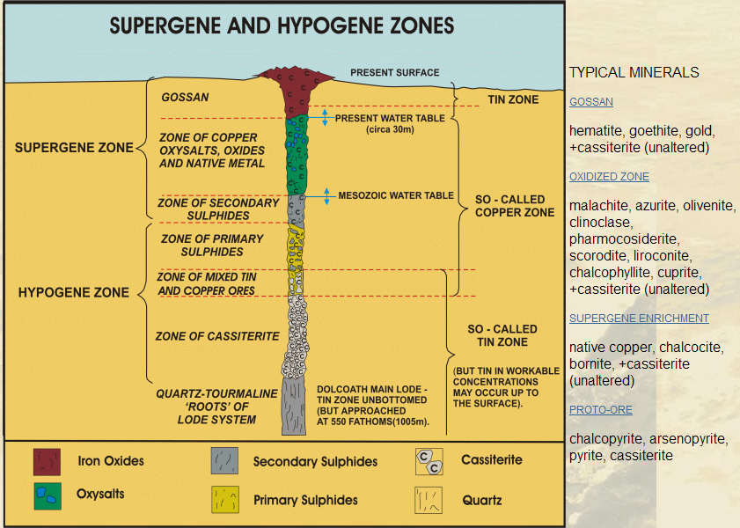

**Personal polished section: BG11- Kudaibergenova Cholpon**

**• Name and chemical formula:** Pyrite **–** FeS2

**Shape:** Cubes usually euhedral, but subhedral to anhedral grains may occur.

**Bireflections:** No

**Anisotropy:** Rare and difficult to see

**Internal reflections:** No

**Relative reflectance:** high reflectance

**• Name and chemical formula:** Galena - PbS

**Shape:** Occurs as anhedral aggregates to euhedral cubes

**Bireflections:** No

**Anisotropy:** No

**Internal reflections:** No

**Relative reflectance:** medium reflectance

**• Name and chemical formula:** Chalcopyrite- CuFeS2

**Shape:** Usually anhedral and very rarely well development tetrahedras

**Bireflections:** Yes

**Anisotropy:** Yes

**Internal reflections:** No

**Relative reflectance:** high reflectance

**• Name and chemical formula:** Pyrrhotite – Fe1-xS

**Shape:** Usually as anhedral grains

**Bireflections:** Yes, creamy brown to red brown

**Anisotropy:** Yes, yellow-grey to grey-blue

**Internal reflections:** No

**Relative reflectance:** medium reflectance

**• Name and chemical formula:** Sphalerite – (Zn,Fe)S

**Shape:** Usually as irregular anhedral aggregates

**Bireflections:** No

**Anisotropy:** No

**Internal reflections:** No

**Relative reflectance:** low reflectance

**• Name and chemical formula:** Chromite – (Fe,Mg)(Cr,Al)2O4

**Shape:** Subhedral to euhedral grains are common, or coarsely crystalline aggregate

**Bireflections:** No

**Anisotropy:** No

**Internal reflections:** No

**Relative reflectance:** low reflectance